***README***

The Project is a "HOTEL MANAGEMENT SYSTEM". Its made in JetBrains IDE "INTELLIJ IDEA".

***PROJECT STRUCTURE && EXCECUTION***

* Open the folder named **HMS** as IntelliJ project folder.
* After that we must add some external libraries to ide.
* Firstly, we have to setup javafx for IntelliJ. It is shown in the video below <https://youtu.be/BHj6zbH3inI>
* Now we must add .jre file for SQLite to work. so for this we have to download **sqlite-jdbc-3.30.1.jar** file. Then we have to go to file>project structure.

After that click Libraries in side pane. Click on **+** and select **Java** and then give path to jar file

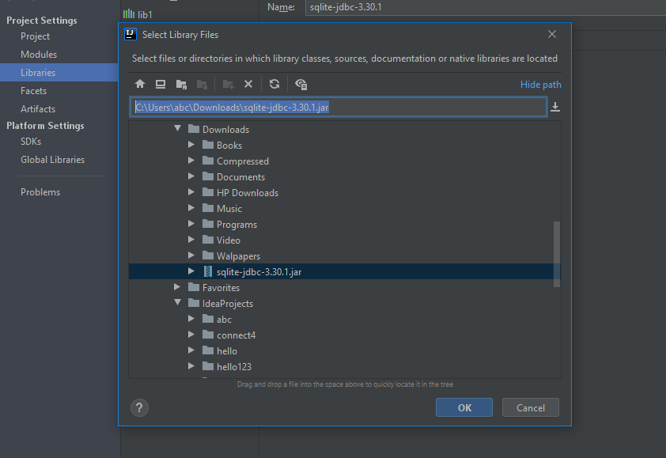

After that click ok .

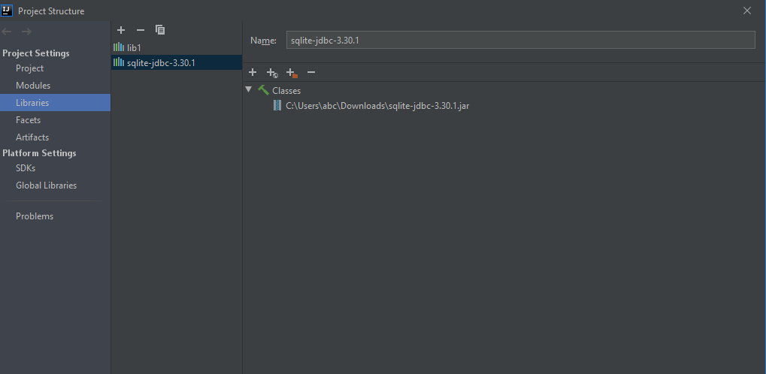

Now hit apply and we are set to go.

* Now open Main class from side pane by double clicking on it . After that hit run and code will run/execute.

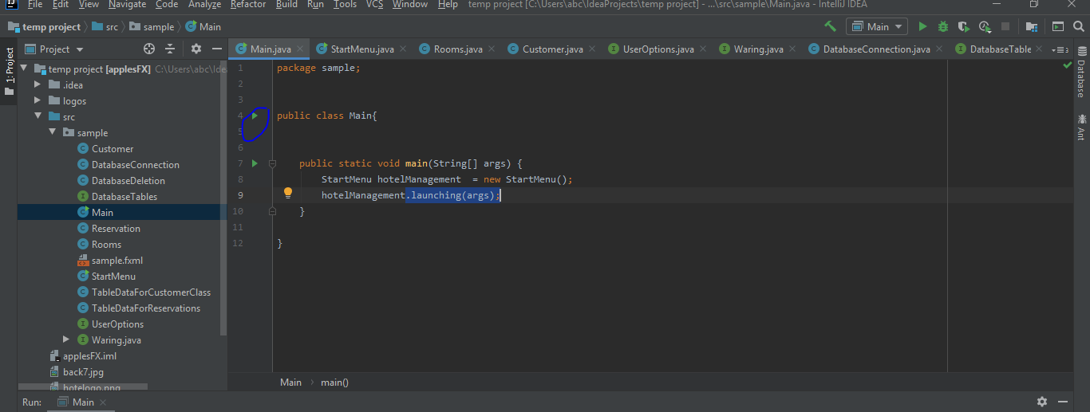

**For Eclipse**

As intellij projects are not fully compatible with eclipse so we have to do some tweaks

Details are :- <https://www.jetbrains.com/help/idea/exporting-an-intellij-idea-project-to-eclipse.html>